AchievAbility e journal 25
Neurodivergent People in Creative Education and Employment
- Introduction
This article discusses; -
- The origins of the term creative industries and the value of the creative economy in the United Kingdom (UK).

- The importance of Creative Education to the Neurodivergent (ND) Community.

- The success of the Higher Education widening participation agenda in increasing the number of ND graduates, who have studied creative disciplines and how these graduates go on to enjoy careers in the creative economy.

- What are the Creative Industries.
The term "Creative Industries" was coined, in the mid-1980s. According to anecdote the phrase was first used, during a disagreement between Greater London Council Leader Ken Livingstone and Prime Minister Margaret Thatcher. Livingstone sought funding for street artists, entertainers, and musicians, while Thatcher considered this an inappropriate use of public money. To secure grants for these individuals, Livingstone reclassified them as "Creative Businesses," enabling them to qualify for funding as entrepreneurs.
Acceptance that the Creative Industries were an important business sector grew in the 1990s. The Department for Culture Media and Sport (DCMS) Mapping Document 1998 defined the Creative Industries as -
“Those activities which have their origin in individual creativity, skill and talent and which have a potential for wealth and job creation through the generation and exploitation of intellectual property” (Cross 2022)
Employment in the creative sector is growing at nearly five times the pace of the rest of the economy (Creative UK 2025). The Sector contributes £124 Billion Gross Value Added (GVA) (House of Lords 2025). It directly employs 2.3 million people. A further 1.3m people work in creative occupations such as marketing or design in non-creative businesses like banks or retailers (Department for Culture Media and Sport 2023). In total 10% of the UK workforce 3.5 million people work in the creative economy.

Diagram 1 – The Creative Industries in the UK
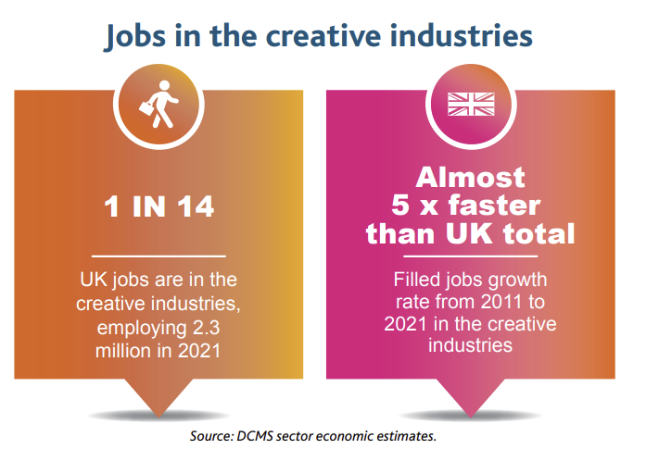

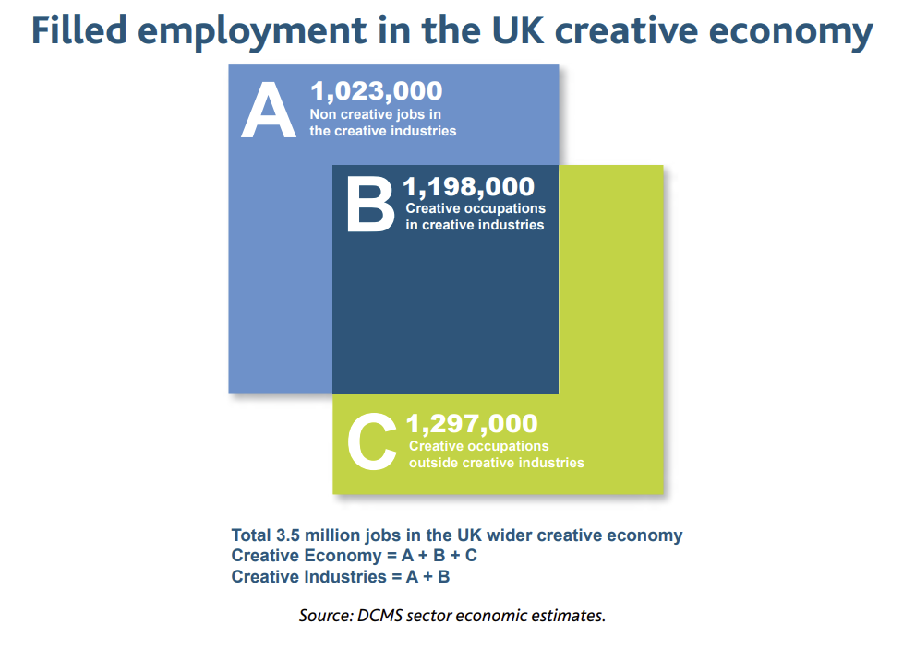
(Department for Culture Media and Sport 2023)
The fastest growth rates occur where the Creative Tech and Digital Sectors overlap. This segment is known as Creative Tech or Createch. It includes software design, interactive marketing, interactive entertainment (such as games), VFX animation and the use of immersive technology, post-production, and computer-aided design.
Diagram 2- Createch – The Overlap of the Creative Digital and Tech Economy.
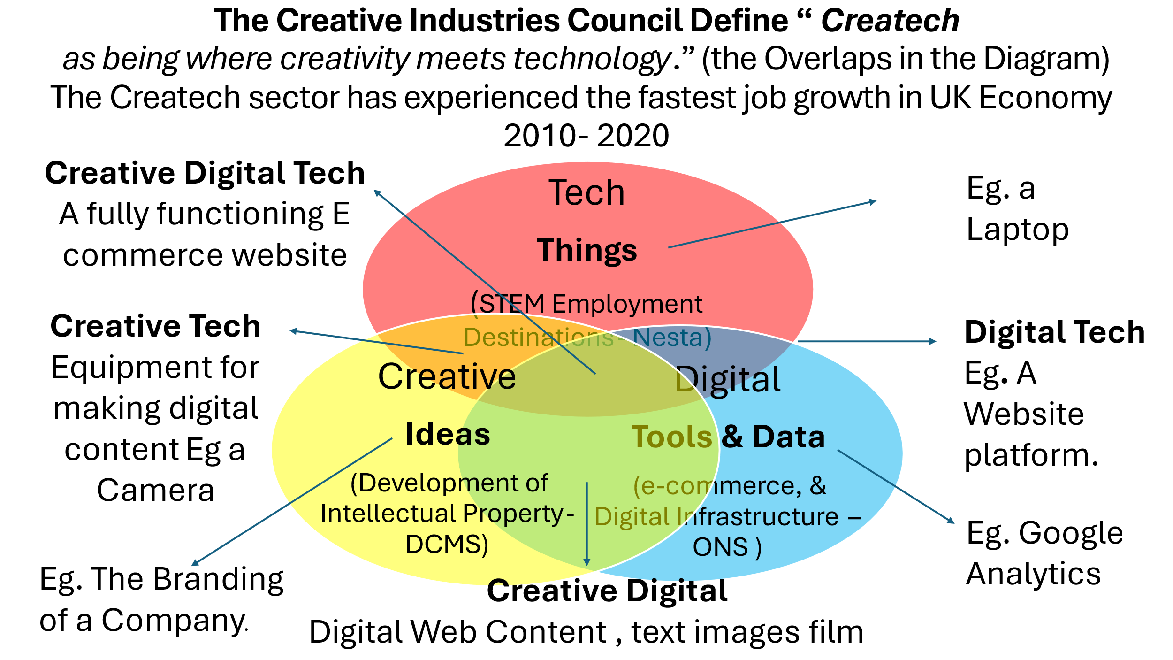
(Freeman 2016)
Sectors with the highest Createch components are highlighted in table 1. Parts of the design, electronic publishing and backstage aspects of the performance sectors would also qualify.
Table 1 - Creative Industry Jobs all UK Regions
Creative Sub Sector | 2010 | 2023 | Change
Advertising and Marketing | 142 000 | 240 000 | 69%
Architecture | 98 000 | 110 000 | 12%
Craft | 7 000 | 3 000 | -53%
Design Product Graphic Fashion | 112 000 | 139 000 | 24%
Video, TV, Film, Radio, Photography | 190 000 | 279 000 | 47%
IT and Computer Services including software design | 448 000 | 1 035 000 | 130%
Publishing | 198 000 | 211 000 | 7%
Museums Galleries and Libraries | 95 000 | 68 000 | -28%
Performing and Visual arts | 233 000 | 277 000 | 19%
Total Creative industry Employment | 1 523 000 | 2 392 000 | 57%
(ONS 2024)

Creative jobs are highly skilled and are often well paid. Graduates make up 72% of the workforce (PEC 2022). Employees in this sector earn roughly 25% more than the average income (House of Lords 2025). The industry also relies heavily on self-employed individuals. 28% of the creative labour force freelance. The average for the rest of the economy is 13%. Freelancers typically earn less than employed creatives (Arts Industry 2024).
- Neurodivergent People in Creative Education
Ken Robinson argued that creativity is a natural human capacity which can be nurtured in all individuals (Robinson 2006). While many of us in the Neurodivergent community struggle with aspects of education which rely on memorising facts or spellings, we often perceive ourselves to have a relative strength in tasks which involve creativity. Dr Helen Taylor in her Theory of complimentary cognition (Taylor 2019), goes as far as to suggest the evolutionary purpose of Neurodivergence may be to ensure that within the population some people will always come up with different solutions to problems. Taylor argues diversity in thinking styles, helps ensure the success of the species.
From the early days of the dyslexia movement in the 1950s the curious relationship between creativity dyslexia, (and now neurodiversity) has formed part of the narrative. When I was first diagnosed in the late 1960s education professionals recommended that art should play an important role in my education.
Diagram 3 – Picture by Charles Freeman.
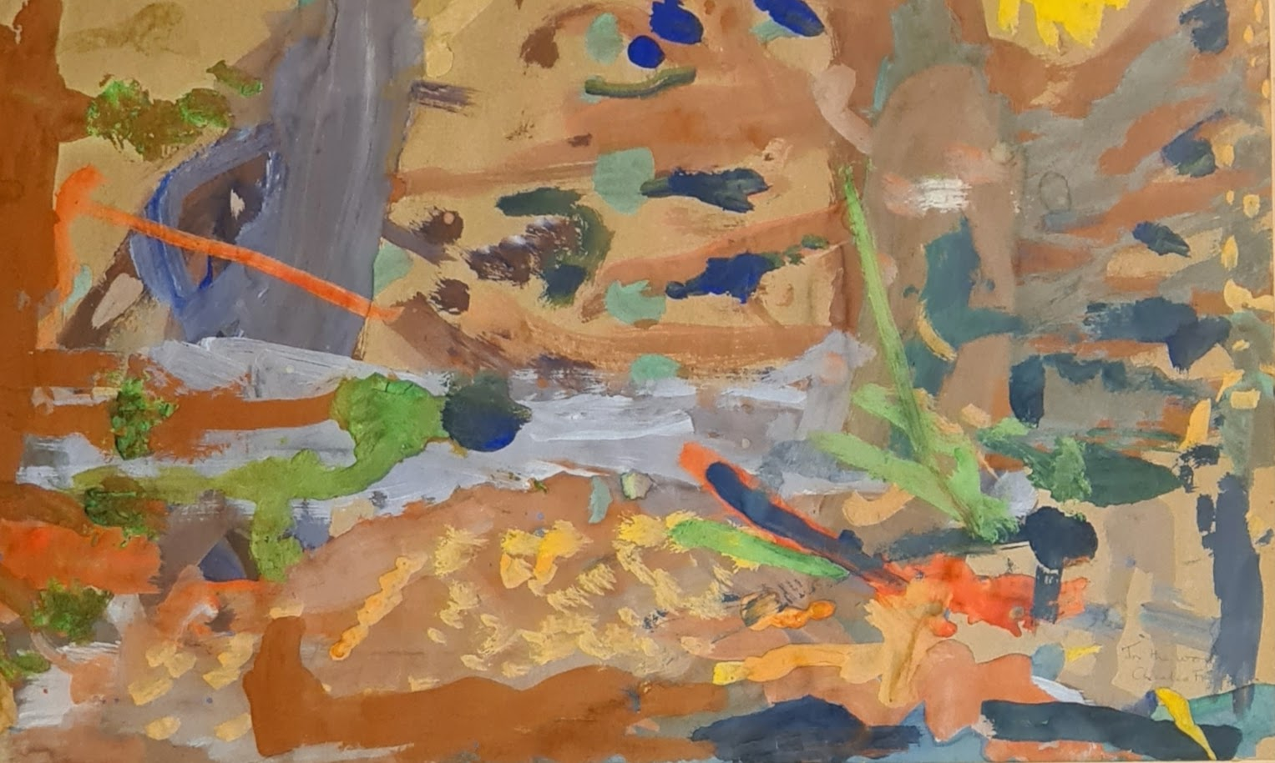
Picture (Autumn Woods) I Drew aged 5 when my Dyslexia was first suspected.

It was not clear if this was because:
- Artists as disparate as Leonardo da Vinci and Walt Disney, who were reputedly dyslexic might inspire me.

- Engagement in creative activity might act as a form of therapy. It was suggested that music could improve mathematical skills and that craft might moderate my behaviour.

- I might have creative talents which could lead to employment.

All three points may be relevant. Fee-paying schools such as Millfield in Somerset, which was one of the first schools to provide specialist dyslexia support, have included art and creativity in their curriculum since the 1940s. (Millfield School 2025).
Even so a tension exists between the cautious advice of professionals and the self-confidence of creatives with lived experience.
In the Dyslexic Child (1970) Macdonald Critchley reflects thinking of the time.
“An inconsistency applies to the artistic abilities of Dyslexics. Ordinarily their achievement is average, while some seem to be peculiarly inept.” (me included)
Critchley goes on to note
“Some dyslexics draw well. He then reports that “Some Dyslexic Children take a particular pleasure in a colourful world of fantasy, invent fantastic stories and do elaborate handicraft”
(Critchley 1970)
By way of contrast, In the foreword to the Universal Music Creative Difference report (2020) Florence Welch remarks
“At School, the phrase I heard most regarding my dyslexia was learning difficulties. Not exactly helpful or accurate”
“My thoughts are disordered not especially logical and not at all linear – but that’s okay, they take me to more interesting places. As an artist, I think it’s a self-evident truth, that not thinking like everyone else is positive and beneficial” (Welch 2020)
- What data tells us about the progression of ND people from education to creative careers
Creative careers are often viewed with scepticism. In the stage play The History Boys (2004), Alan Bennett conveys the prevailing views of the establishment, the press and many teachers, through his character Mrs. Lintott.
“When I was teaching in London in the seventies there was a consoling myth that not very bright children could always become artists. Droves of the half-educated left school with the notion that art was a viable option” (Bennet 2004)
Data shows the reality is different, ND people are succeeding at university and earning a living in the creative economy.
Statistics on the number of ND students studying creative subjects in school are scarce. However, anecdotes suggest many ND students choose creative subjects at GCSE and A level.
Further education (FE) colleges report a high number of ND students enrol on creative courses. 32% of students on creative courses disclose disabilities or health conditions, compared to 24% across all courses (Carey 2024). With 22% of FE students being ND, this suggests a disproportionate representation of ND students on FE creative courses (Gains 2024).
The Higher Education Statistics Authority (HESA) collects data on the courses selected by neurodivergent students at university. The data uses two classifications: students with cognitive learning difficulties (such as Dyslexia or ADHD), and students with communication impairments, primarily Autism Spectrum Condition. (House of Commons 2021)
Table 2 - Extracted from HESA data on students with disabilities at UK universities. Workbook: E and D official dashboard 2022 (hefce.ac.uk) (See separate table to be substituted)
(Higher Education Statistics Authority 2022)
The proportion of neurodivergent students enrolling in creative degrees (10.5%) is higher than in any other academic discipline. 50% higher than the average. This figure increases to 12% among graduates. It is likely that these figures are underestimates. Many neurodivergent students are never diagnosed. (BBC 2019). Others may choose not to disclose due to fear of stigma or discrimination. (AchieveAbility 2018) Some estimates therefore suggest the number of ND students studying creative courses could be as high as 25%. (Rankin 2006).
Data on the progression of Creative Graduates into Employment is also encouraging. Creative Arts Courses boast the highest levels of employment across any discipline for graduates with disabilities (Prospect Luminate 2024). The actual outcomes for ND graduates require further investigation. The circumstantial evidence is positive. Over 40% of all students with disabilities studying creative disciplines are ND. It is therefore highly likely Prospect statistics reflect the progression of ND creative graduates into employment.
According to the House of Commons, non-autistic ND students have the same likelihood of being employed as graduates without disabilities, while autistic graduates have a 62% chance of securing skilled employment (House of Commons 2021). This contrasts with the average employment rate for all autistic people, which stands at 26% (DWP 2024). Alarmingly, by mathematical extension this statistic suggests less than 10% of autistic non-graduates are employed.

Diagram 3 – Employment of Graduates with Disabilities by Subject Area. See separate Graph to be substituted.
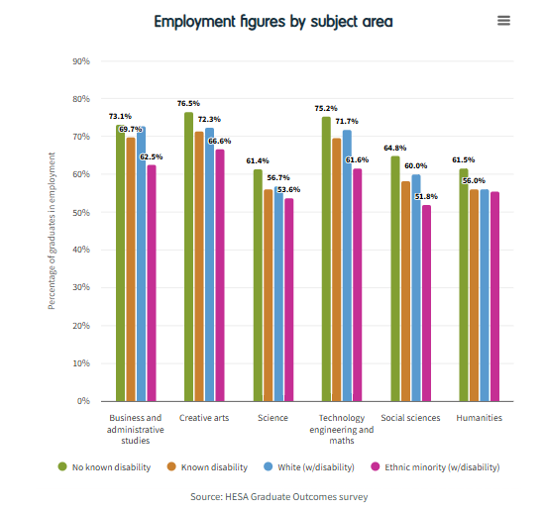 (Prospect Luminate 2024)
Creative Graduate Creative Futures (Ball 2009) identified that dyslexic and likely all non-autistic neurodivergent graduates are more often employed than their peers but tend to work differently. They are more likely to freelance, be on short-term contracts, or have portfolio careers. They also generally earn less than their peers graduating from the same course.

Diagram 4 - Mode of Employment of Dyslexic Creative Graduates.
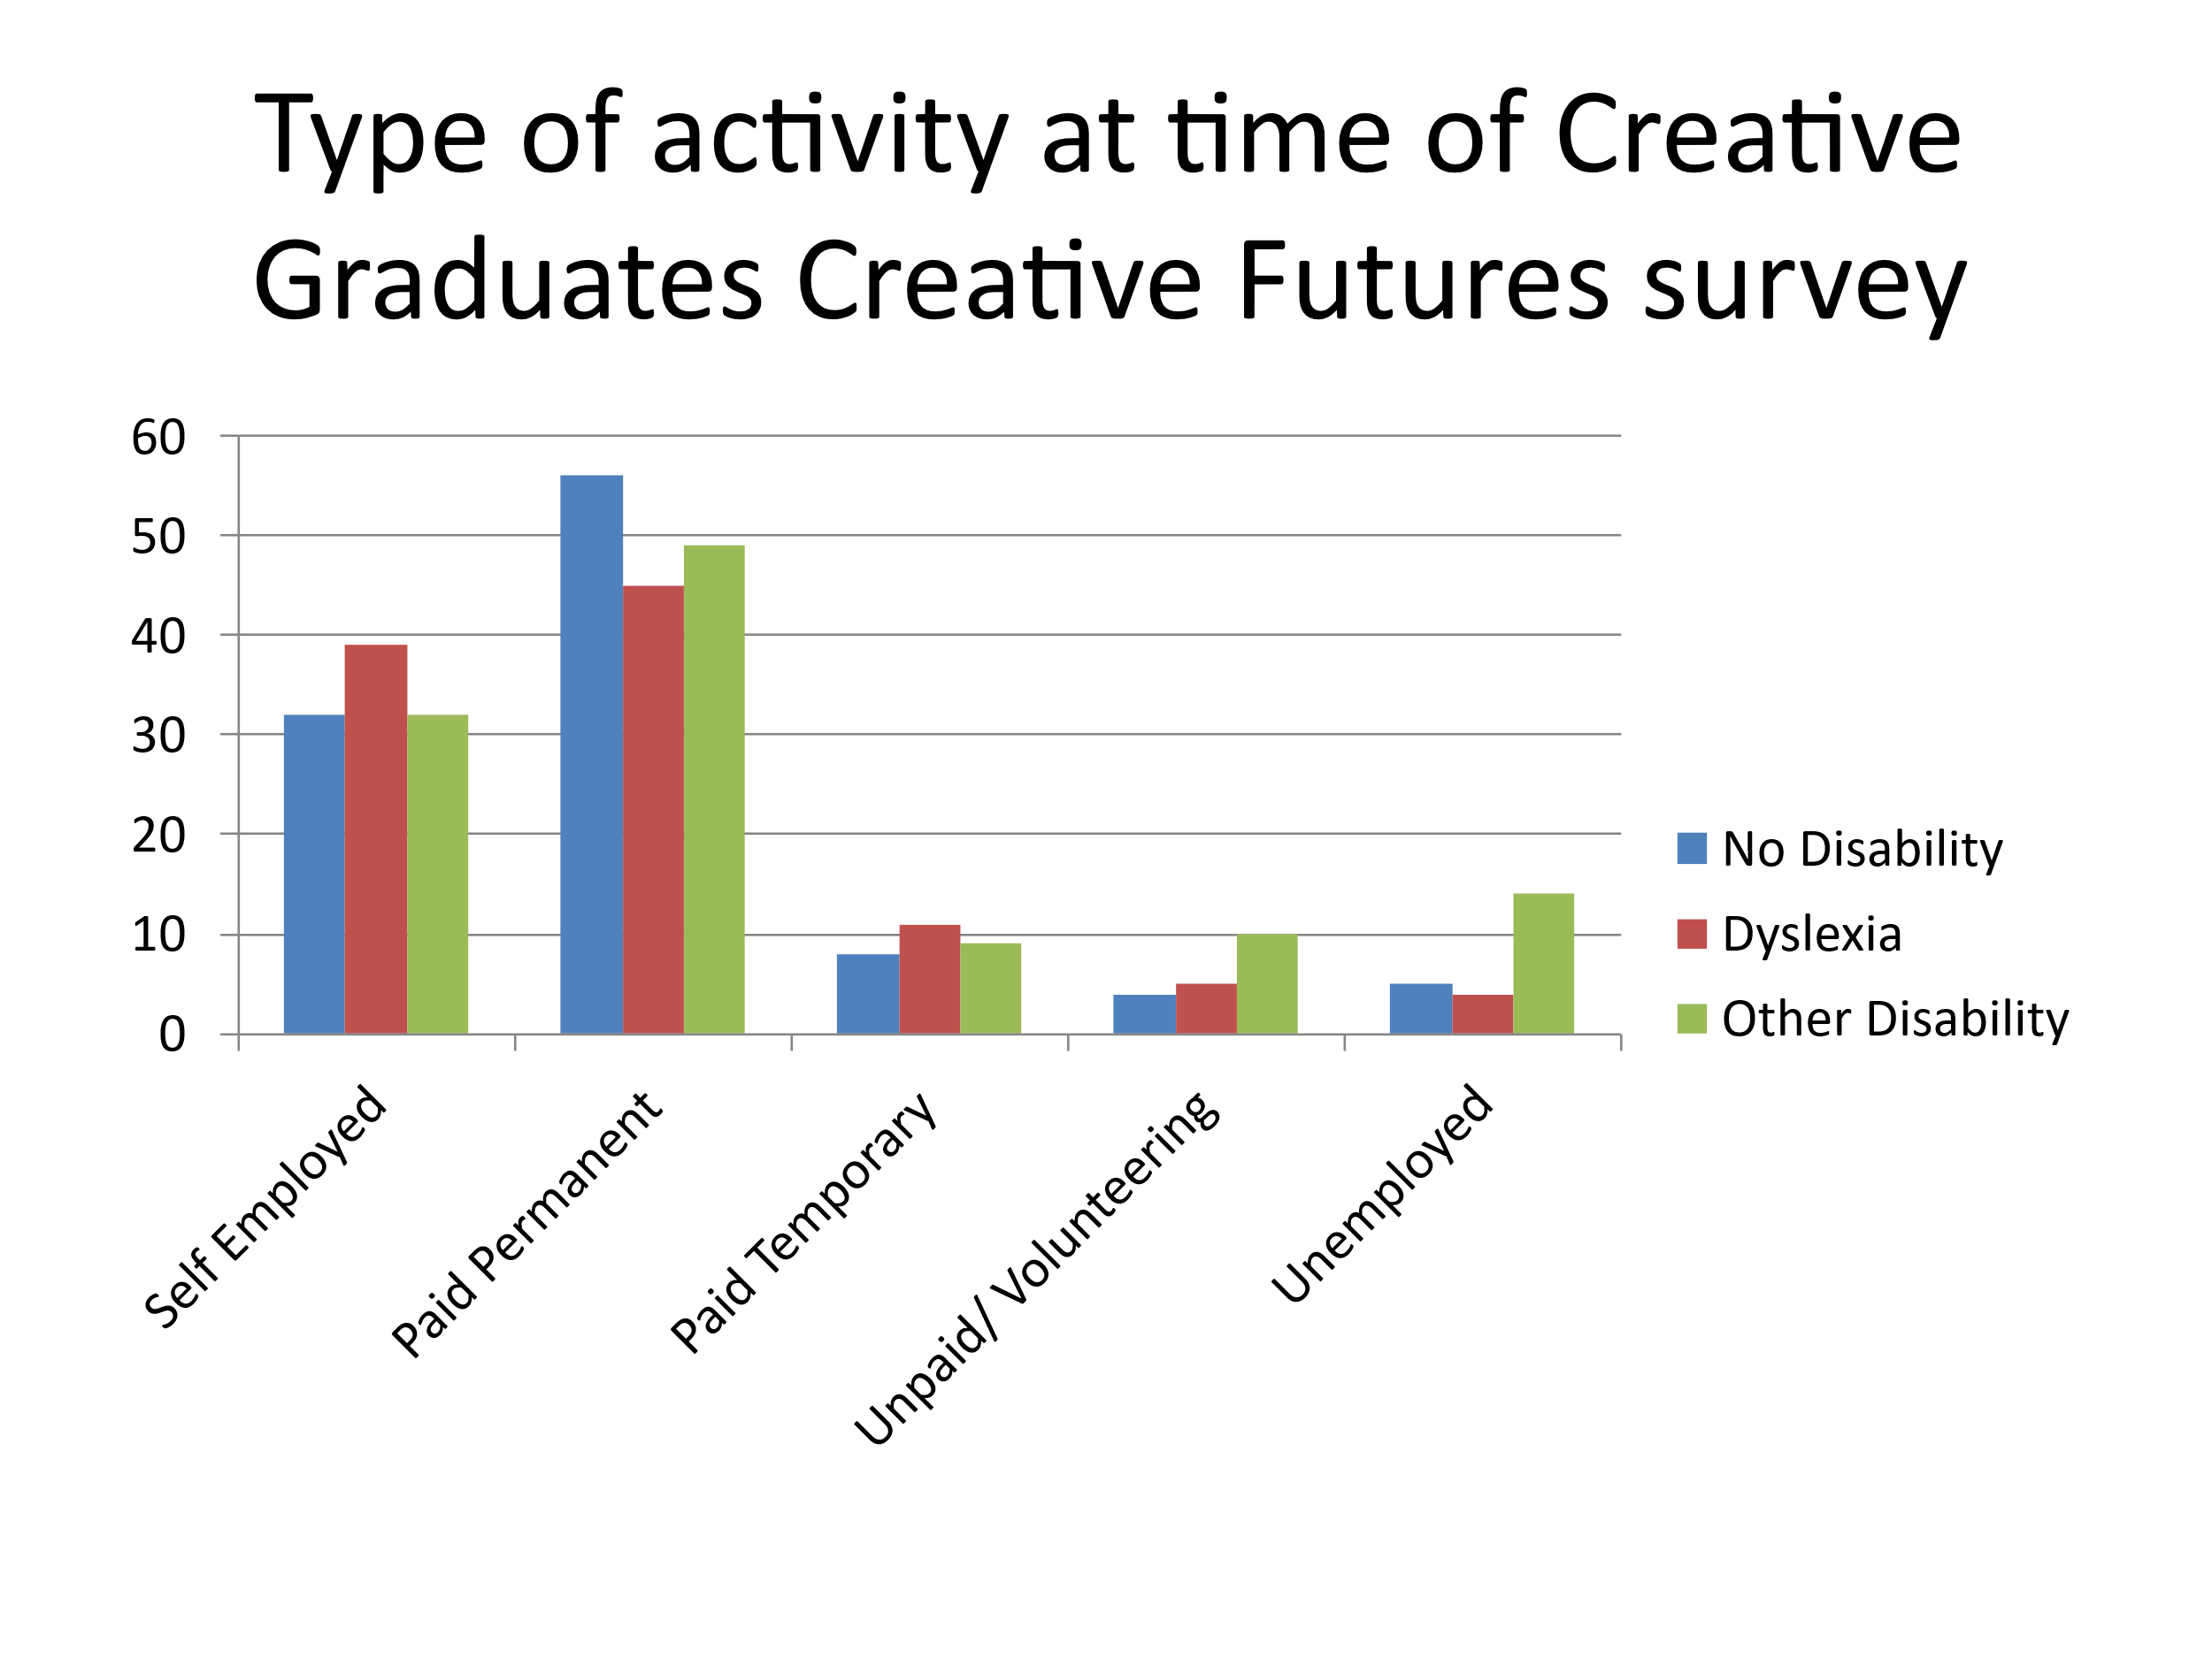 | 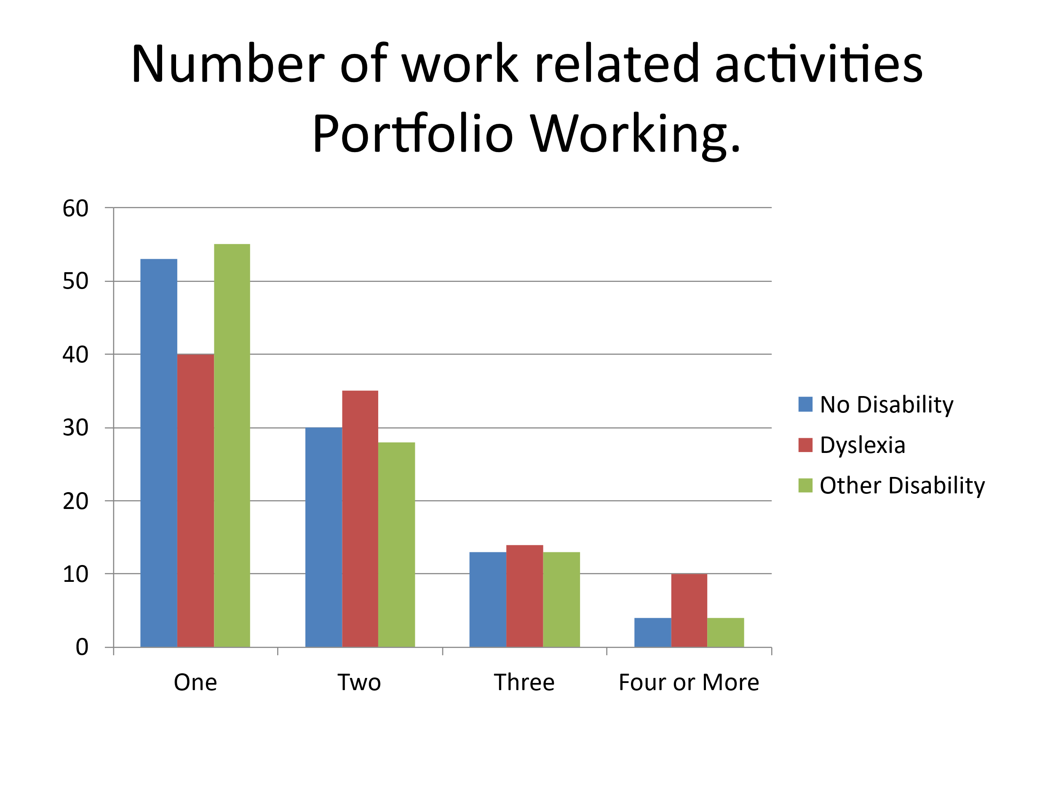
Adapted from Creative Graduates Creative Futures (Ball 2009)

Available industry surveys seem to focus on Createch (the intersection between creativity and tech) In particular Digital Marketing, Immersive technology, VFX, games, and software design. These surveys reveal an interesting pattern of neurodivergent employment.

Table 3 – Industry Survey Findings Regarding Percentage of ND people in Creative Industry Employment

 |  | Total ND Representation | Dyslexia | ADHD | Autism | Reference
Estimated incidence in population |  | 15%  (NHS 2025)  3.23% Formally Diagnosed  12.97% Self Diagnosed (Apperly 2024) | 10% (BDA 2025) 2% Diagnosed in School (BBC 2019) | 5% Children  3-4% Adults  (NHS 2024)  0.32% Diagnosed (ADHD UK 2025) | 1-3% (NAS 2024)  0.82% Diagnosed (O'Nions 2023)
Industry Body | Sector
Creative Equals | Advertising and Marketing | 18% | Na | Na | Na | (Kiefer 2021)
British Interactive Media Association | Interactive Marketing | 23% | Na | Na | Na | (BIMA 2019)  Note survey included Freelancers)
Screen Alliance | VFX Animation  Post-Production | 9% | 6.5% | 2.2% | 1.3% | (Screen Alliance 2019)
UKIE | Games | 18% | 7% | 10% | 4% | (UKIE 2022)

The Tech Talent Charter Tech Diversity Report reveals that only 3% of employees are identified as neurodivergent by industry employers. However, when tech employees were asked directly, 53% self-identified as neurodivergent.
Tech Talent Charter (Employee responses) | Tech | 53% | 9% | 15% | 15% | (Tech talent Charter 2024)

These survey results raise key questions:
- The proportion of dyslexic people revealed by the surveys to be working in sectors surveyed is lower than might be expected. It is lower than the estimated representation in the general population, and the representation reported at university. (But higher than the number officially diagnosed at school)

Possible reasons might include

- Most dyslexic people are never diagnosed, and don’t know they are dyslexic. (BBC 2019).

- According to Creative Graduates Creative Futures, (Ball 2009) The highest representation of dyslexic students at university occurs on design, architecture, performance, and visual arts courses, representation on Createch related courses is lower. Further evidence is required to confirm this observation.

- A disproportionately large number of dyslexic people working in the creative sector are freelance or self-employed. Dyslexic people are underrepresented in the directly employed workforce. Surveys often focus on directly employed staff rather than freelancers. They therefore miss many dyslexic people working in the sector.

- Upon graduating, some individuals with dyslexia may choose not to identify as neurodivergent. They may find it distressing or fear discrimination (AchieveAbility 2018)

Autistic and ADHD people are significantly overrepresented in the Createch sector, compared to other parts of the economy. For example, the UKIE survey summarised in Table 3 identifies that 10% of the games sector workforce identify as having ADHD, twice the estimated prevalence in the population. 4% of Games professionals identify as being autistic more than twice the incidence in the population and more than 5 times the representation of autistic people in the workforce.

Possible consequences
- Although it is wrong to stereotype autistic individuals as having technical skills, it is important to acknowledge that the Createch sectors provide significant employment opportunities for autistic and neurodivergent people. Approximately 30% of all autistic graduates appear to work in the Createch footprint. This has implications for professional development training.

- Autistic individuals in Createch significantly outnumber those graduating from creative university courses, indicating the sector attracts autistic graduates from non-creative disciplines. Eg. Engineering Technology and Computing.

- Many autistic individuals are diagnosed later in life. Some people in the sector may not realize they are neurodivergent until a significant life event occurs. Typically, a child might be diagnosed, or a work challenge may occur.

- Amanda Kirby explains that a diagnosis depends on the perspective of the professional evaluating an individual (Kirby, 2022). One reason for the seemingly low representation of dyslexic individuals and the high representation of those with ADHD and Autism in the sector is that neurodivergent individuals exhibit overlapping traits. Consequently, they may opt to identify as autistic or having ADHD rather than the dyslexic label. Particularly if this provides a more effective or acceptable pathway to accessing the support they need.

- Conclusions
Not thinking like everyone else, (Welch 2020), can give ND people a competitive advantage in the Creative Economy.
The divide between creative which are often viewed as offering poor employment prospects and Science Technology Engineering and Maths (STEM) courses which are perceived to offer good employment prospects is when it comes to ND students misleading. Creative education offers ND students an accessible route to tech jobs.
Creative Careers can be risky. A high proportion of ND students find their pathway to a viable income by freelancing or by taking on short term roles. High student fees and the prospect of insecure employment, stop many ND people from disadvantaged families from following their passion, and accessing a path to success which is well trodden by more privileged ND people.
The number of openly neurodivergent students graduating from university has risen from approximately 0.5% (1 500) students in 1995 (Department for Inovation Universities and Skills 2009), to approximately 7% (23 000) in 2021 (Higher Education Statistics Authority 2022).
The increase in ND graduates and their success in finding jobs according to graduate outcome data (House of Commons 2021), represents an extraordinary success.
This success is attributable to the Higher Education widening participation agenda pursued by successive governments. This success needs to be celebrated. It should also be acknowledged that creative courses have been at the forefront of the expansion of Higher Education and the widening participation agenda. These achievements are at risk. The Government is currently proposing that the funding of creative courses should be given reduced priority. (Department for Education 2025). Further funding cuts in this area will damage the employment prospects of ND people.
It should be further recognised that money invested via special education needs budgets, in supporting ND people in schools and further education, so they can get to university or access work-based learning programmes yields massive life cycle savings to the treasury. (Coles 2010) Similarly, investment in student support at university and in helping ND students make the transition from Higher Education to work delivers both a significant economic dividend for society and enhanced quality of life for the individual. For example, the SEEDS program at Ravensbourne University, has achieved a 97% employability success rate, since it was established in 2014 (Ravensbourne University 2025). More simular initiatives should be encouraged.

I was told this story in 2005 by a former senior civil servant at the Department for Trade and Industry. Ken Livingston was leader of the GLC from 1981 until it was abolished in 1986. Margaret Thatcher was Prime Minister from 1979 to 1990. I was also told a variation of the same story by the Rt Hon Lord Smith of Finsbury former Secretary of state for Culture Media and Sport.
The History of the first 90 years of Millfield and its prominent role in pioneering support for dyslexic pupils is set out in the following article https://www.millfieldschool.com/discover-brilliance/our-history#:~:text=In%201942%2C%20Martin%20Attlee%2C%20son,deal%20successfully%20with%20dyslexic%20students.
This calculation is based on roughly 1/3rd of autistic people graduating. Current data suggests 1.5% of School population are autistic, and that 0.9% of graduates are autistic. 50% of general population go to university so it can be calculated just over 30% of Autistic People
DWP estimate only 26% of autistic people are in employment (DWP, 2024). NAS estimates 1-3% of the population are autistic. Assuming the higher figure of 3% of the population are autistic the average representation in the labour force is 3% X 0.26% = 0.78%. Over representation in the games sector is 4/0.78 =5.13 fold over representation.
Approximately 2/3rds of all creative employment could be classed as Createch. Roughly 2m Jobs. 72% of these Jobs employ graduates and roughly 4% of the workforce are Autistic. Therefore about 58 000 autistic graduates work in the sector. The UK working age population not in education is approximately 40m. Around 1.5% of this population will be autistic of which 1/3rd will be graduates. The are therefore around 200 000 working age autistic graduates in the UK. 58 000/200 000 = 29% of autistic graduates work in Createch.

