NDnomics 17 - Wicked Problems and Neurodiversity

Charles Freeman 2025

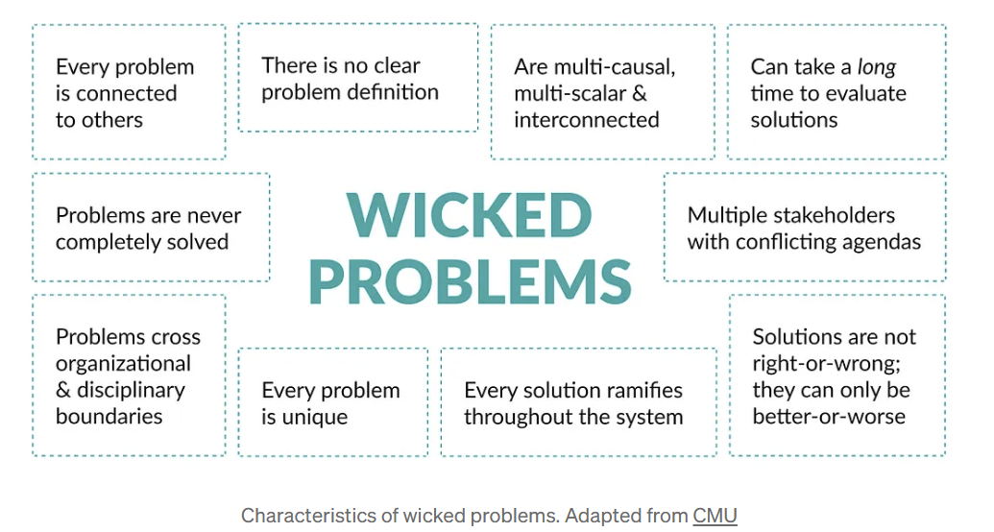 (Kučerová, 2022)

Introduction
This Blog seeks to:-
- Explore the way in which neurodivergence provides an often-unaddressed thread linking many of the most complex social policy issues.

- It speculates that a misunderstanding of the relationship between, Neurodiversity, Disability and Inclusion contributes to neurodiversity being ignored as a driver of exclusion.

- It argues that a better and more consistent understanding of neurodivergence across public sector bodies could yield better outcomes for ND individuals and significant savings to the treasury.

What are Wicked Problems.
A wicked problem is a problem that is difficult or impossible to solve. (Wickepedia, 2025) The term was first coined by Horst Riddell in 1973. Horst contrasted tame problems which could be solved using standard scientific method, with wicked complex, policy-based problems, which were neither simply nor completely resolvable. (Johnston, 2022).
Topical examples of social policy wicked Issues which relate to neurodivergence include:-
- Provision for Special Education Needs.
- School Exclusions
- Young People Not in Education Training or Employment (NEET)
- The growth in people on long term out of work benefits
- Substance abuse, justice interventions and growing prison populations.
- Homelessness
In all the above cases Neurodivergent people are disproportionately represented among the groups at risk of the worst outcomes. Neurodivergence is however rarely spoken about in mainstream policy discussions concerning these topics.
The available data sets are inconsistent, Different public services use different definitions. The UK Governments Disability Action Plan Consultation 2023-24 made 13 mentions of neurodiversity. Eight refer to the Department for Justice, which has a neurodiversity action plan. Other departments such as the Department for Health and Social Care, The Department for Work and Pensions and Department for Culture Media and Sport focus exclusively on autism. No Mention is made of Dyslexia, Dyspraxia or ADHD. The final Action Plan dropped the term neurodiversity altogether (See NDnomics - 8 Neurodivergence and Data (Freeman, 2024).

Table 1
Percentage Neurodivergent

Special Education Needs Approximately 1.45m pupils have special educational needs in the UK.
1.05 M 72% of SEN pupils are ND. They have speech language or communication, Social Emotional or Mental Health, Autism or Specific Learning Difficulties diagnosis. (Freeman, NDnonics 15 Drill Baby Drill, 2025)
0.4m 28% of SEN pupils have physical disabilities, sensory impairments, complex needs, severe or moderate learning difficulties. (Therefore, not primarily ND)
School Attendance 92% pupils with attendance difficulties are ND (Authenticaly Emily , 2025)
School Exclusions Children with Autism are more than twice as likely to be excluded from school compared with other pupils. (Ambitious about Autism , 2018)
People on Out of Work Benefits 30-40% of Neurodivergent people are not in employment (G2 Legal, 2023) compared to 21% of the population who are not economically active (BBC News, 2025)
Substance Abuse People with ADHD at 4 times higher risk of substance abuse compared to general population. People with other ND Conditions also experience higher risk (Maier, 2025)
Justice Interventions 50% of Prison Population Dyslexic (Prision Service Journal, 2022)
Homelessness 12.3% of people experiencing homelessness are autistic a 10-fold increased risk compared to the general population. (Transforemation Partners, 2024)

3) Why Is Neurodivergence a hidden issue in Public Policy

3.1) A fear of pathologizing disadvantage
The medicalisation of disadvantage and poverty has a grim history. The relationship between poverty and poor health is complex. Frequently rather than recognising that poverty, unfair working conditions, inadequate housing and discrimination are a cause of poor mental and physical health, politicians have sought to victim blame by attributing poverty to the mental state (stupidity) of people who experience disadvantage. (Seabrook, 2012)
In the 1960s and 1970 Black students were frequently over diagnosed and sent to schools for the “educationally subnormal” due to institutional prejudice within the education establishment. (McQueen, 2020)
At a micro level, giving a person a medical label can have serious consequences. It will often bring with it stigma; it can act to reduce the expectations of teachers’ family members and friends. It can be a self-fulfilling prophecy leading to reduced life chances. On the other hand, a diagnosis may be the key to self-understanding and accessing the support needed to achieve success. (Kirby A. , To Label or not to Label, 2025)
At a macro level Professionals have good reason to not want to attribute disadvantage to a medical label such as neurodiversity. This could have highly negative consequences for the ND community if they were then stereo typed as being likely to be unable to succeed at school and at high risk of criminal behaviour. On the other hand, not acknowledging the risks ND people face in the education system and in the workplace, makes it harder to put in place policy interventions which could reduce the risks faced by ND people.

3.2) Professionals working in the fields of Education, Employment, Health, Housing and Justice are not trained to recognise neurodivergence as a risk factor
Literature identifying the over representation of ND people within all the above groups frequently notes that professionals working in the field are not trained to recognise neurodivergent traits. Nor are they aware that neurodivergence may put people at higher risk of poor outcomes.
“Neurodiversity is an afterthought at the moment”: results from a pan-London survey of frontline staff’s views about working with autistic people experiencing homelessness”.
(Transforemation Partners, 2024)
Even within initial teacher training understanding of neurodiversity is not mandatory. According to the national autistic society only14% of secondary teachers have undertaken more than half a day’s training about autism. Not surprisingly most autistic pupils don’t believe that their teacher understands them. (BBC News , 2025).
The Ministry for Justice is an honourable exception. In 2021 The Ministry conducted an evidence review of neurodiversity in the justice system. This led to the production of an action plan. One of the actions is that every prison now has a nominated lead officer for neurodiversity. (Ministry of Justice , 2022).

3.3) Government is not joined up and does not use system thinking.
The discussion of the previous governments Disability Action Plan reveals the inconsistency and confusion in government understanding of neurodivergence.
The department for justice has made itself aware that understanding neurodivergence is key to breaking the offending cycle. (Hayes, 2024) However, achieving change is still a work in progress.
Recently I was told a story which illustrates this point. A young autistic man was sent to prison. On his first day his case officer asked him why he had been sent to jail. The man explained he loved trains. One day he had been waiting for a train. He noticed the train was waiting for a signal and no one was in the signal box. He broke in to the signal box. (The door was open). Put on a uniform. Changed the signal. The train arrived and departed safely. The railway company called the police and insisted on pressing charges. The man was sent to prison. The case manager who was ND aware observed that this was not an appropriate sentence. He was able to get the prison sentence replaced with a non-custodial sentence, and eventually to help the man secure a job working with a railway company. The intervention cost around £2 million.
The person who recounted this story, rightly stated this case should never have progressed to the point of the man being sent to prison. Although the police and the court new the man was autistic, this did not trigger an autism aware response. More awareness and understanding would have led to a better outcome sooner and would have saved significant expenditure. Possibly a similar argument could be made regarding more high-risk autistic individuals. If the social workers, schools, police and the justice system were more Neurodivergent aware, better earlier responses might be made. (Daily Mirror , 2025)
Other departments such as the Department for Health, Department for Education and the Department for Work and Pension, often appear to have a culture which perceive extra expenditure on the assessment of ND conditions, support for pupils with extra needs and additional employment support as a cost rather than an investment.
In the 1970s the Warnock review was warned off using the term Dyslexia as the Department for Education could not afford to provide additional support for 10% of the population. (Kirby P. , 2018) . Extraordinarily an official from the Department for Education expressed a similar view doubting the existence of dyslexia when giving evidence to the Chamber UK Dyslexia Commission chaired by Matt Hancock MP in 2022 (Curia, 2022) Negative attitudes to providing support are expressed by many local authorities (BBC News, 2024)
DWP is also trying to make savings by tightening criteria for access to work support. These cuts can be counterproductive. They can force ND people out of relatively secure employment, which enable them to pay taxes and be net contributors to the treasury, into a position where they need to rely on benefits. (Elton, 2025)
Studies which use a life cycle costing approach reveal that relatively low-cost early interventions can yield the treasury large savings over the life of an ND person. They also vastly increase the individual’s quality of life. A 2010 York University study suggests that early interventions costing £10k to £30K per individual can yield savings to the state of £100k to £500k over the individuals life cycle. In aggregate the study suggests early intervention could save between £10 Billion and £30 Billion. The report notes these interventions rarely happen. (Bob Coles, 2010) I believe that the situation has got worse in the past 15 years. Increasing concern being expressed about the costs of out of work benefits which have increased significantly since the pandemic. Much of the increase is attributed to people with mental health and neurodivergent conditions. (BBC Verify, 2025). The opportunity to achieve savings through, taking a system approach and investing in early interventions has therefore also increased.

3.4) Government does not know where to file Neurodiversity
The legal protection Neurodivergent People benefit from in the labour market frames neurodivergence as a disability. However, most neurodivergent people do not identify as being disabled. This is explained well by Disability Wales.
“Not everyone who is neurodivergent will identify as disabled. Many actually like the way their brain works.
They will probably still struggle with aspects of daily living or work, or both, but on the whole, they are managing their lives, so they do not identify as disabled. “
(Diability Wales , Anabledd Cymru, 2024)
Diagram 1 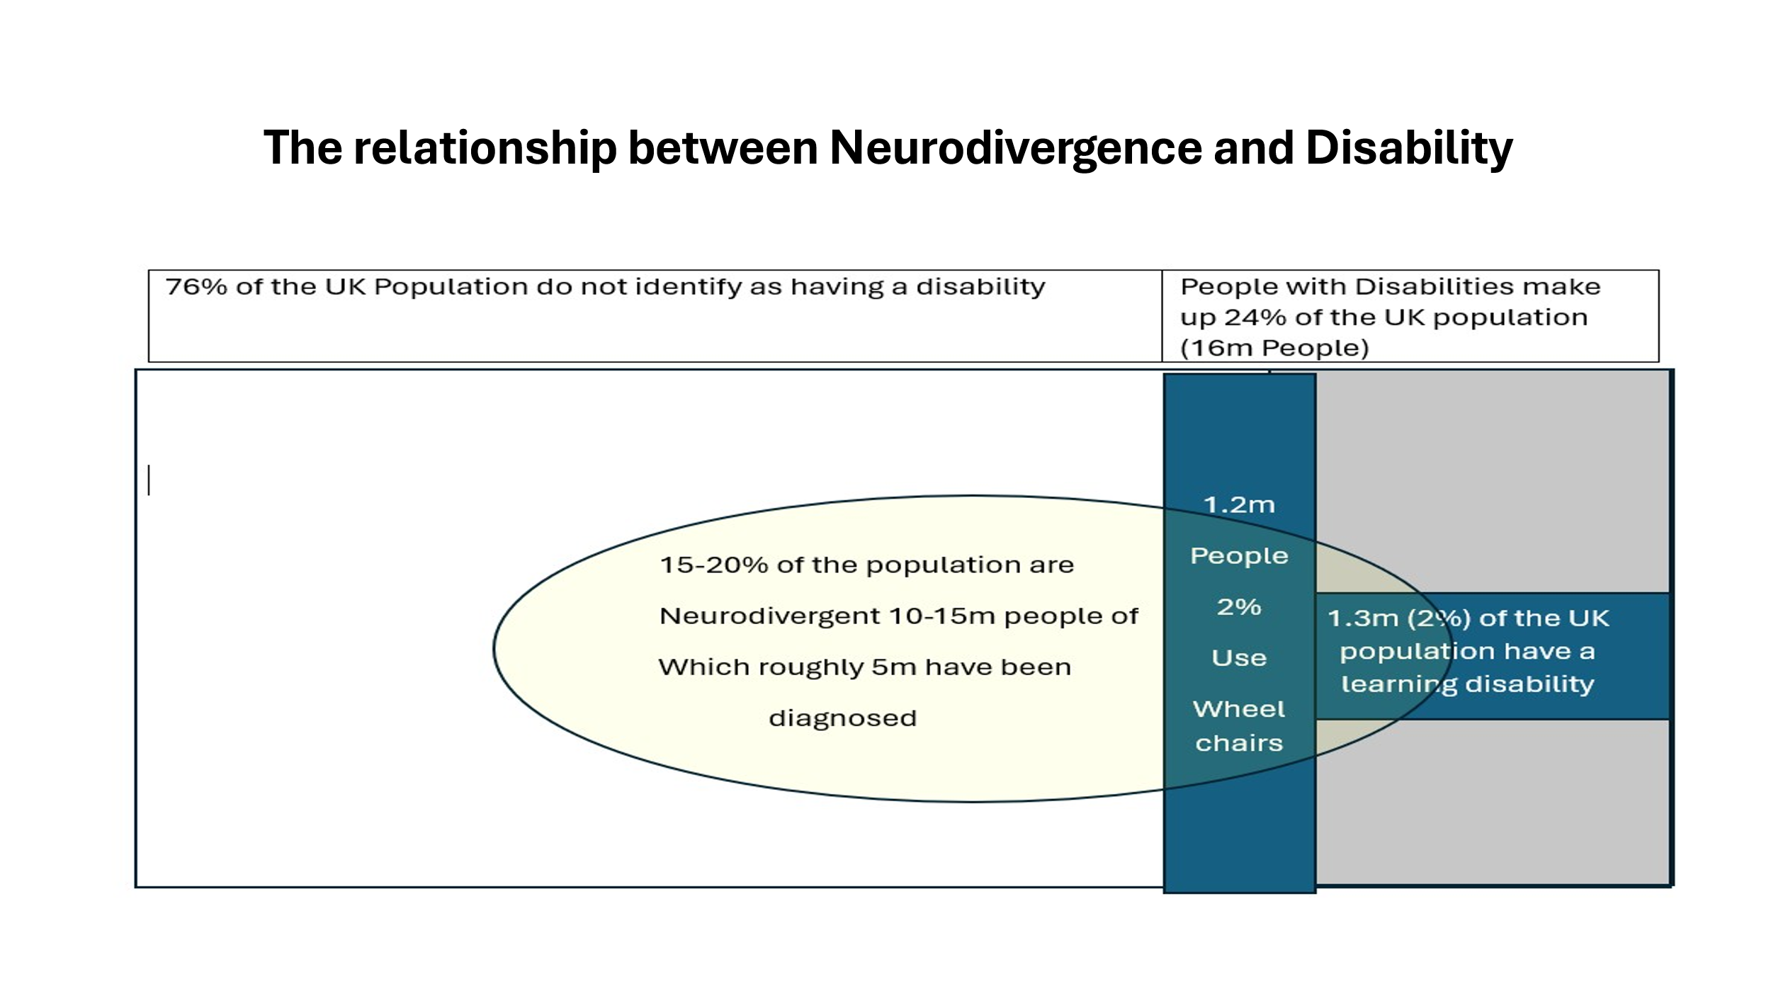 (Freeman C. , 2024).
While many neurodivergent people struggle with aspects of life, some are phenomenally successful. In almost every aspect of life some of the most successful people are openly neurodivergent.
Table 2
Business Bill Gates Richard Branson
Science Stephen Hawking Alan Turing
Music Florence Welsh Solange Knowles
Sport Simone Biles Lewis Hamilton
Film Steve McQueen Whoopi Goldberg

Society has a problem understanding that disabled people in general not just neurodivergent people who are successful in one sphere of life but struggle in other spheres. Culturally too often policy is driven by pity and paternalism rather than a desire to enable individuals to fulfil their potential, live independently and feel empowered to make the most of their strengths.
Frequently society assumes that success is a zero-sum game. In Economic terms this is not true. Over the past 50 years achievement of GCSE passes have increased from 20% of pupils to over 80%, University attendance has increased from 10% of the population to 50%. (Freeman, NDnomics 16 whats changing , 2025). In 1975 the UK economy employed 25M people in 2025 it employs 34M people. The average wage in 1975 was approximately £2 500 per year , the average wage now is £35 000 per year. Increasing education attainment has led to more jobs being created and greater prosperity. Everyone gains the more people are able to prove they are competent to work and fill skills gaps in the economy.
Debate about providing additional support for disabled people, is too often framed in terms of people trying to gain an advantage by gaming the system rather than focusing on ways Disabled and ND people can be supported so they can evidence their abilities. A good example is the discussion about the fairness of extra times in exams or student support for neurodivergent students at university (Pepin-Neff, 2024). It is not a zero some game. One person being supported does not prevent another person gaining success. Levelling the playing field by ensuring ND students are provided with the reasonable adjustments needed to evidence their talent, should not and does not disadvantage other students.
Likewise, the benefit system is designed to provide a safety net for the deserving poor, rather than facilitate people to live independent lives. The Access to work scheme was established to reduce the burden on employers of making adjustments needed so people with disabilities had the same opportunities to work as able-bodied people. If an office is on the second floor a wheelchair user is unfairly disadvantaged from getting a job unless the building has a lift. The access to work scheme however only supports around 60 000 people (Disability Rights UK , 2024). Approximately 1% of the 5.3M people who identify as having disabilities in the UK labour force. The Governments flagship scheme to help disabled people get into work and stay in work is therefore irrelevant to 99% of working age disabled and ND people in the UK. (House of Commons Libary , 2024).
Governments from all parties too often feel compelled to cut the relatively cheap investments they make to help disabled and ND people live independent lives and gain employment, and consequently end up with increased expenditure on long term out of work benefits and health care interventions.

Conclusion

4.1) Being different often leads to disadvantage

The Neurodiversity Paradigm draws attention to the natural phenomenon of everyone’s brains being different. (National Autistic Society , 2025). Some people think in a sufficiently different way to meet the criteria for diagnosis for one or more conditions in the neurodivergent family.

These differences in thinking styles are just as normal as differences in height, finger print, gender, or skin colour. They are part of the human condition and have existed throughout the history of humanity.

Difference from perceived norms of the rule setting hegemony, historically white male and well educated, frequently leads to disadvantage, discrimination and when challenged backlash. This is the context for the development of the feminist, civil rights disability rights and pride movements. The battles ND people must fight are little different from those fought by other groups defined by difference.

However, while ND people and people with disabilities have many common interests, the interests of both groups do not perfectly align. The majority of ND people live mainstream independent lives and do not want to be classified as being disabled. They do however need catalytic support to fulfil their potential. Relying on systems geared to support people with disabilities in order to access support in the educations system does not always serve either ND people or people with disabilities well.
In schools ND people are often competing against students with more profound disabilities for limited special education needs resources. Likewise in the benefit system the argument is made that it is fair to support those who can’t work due to profound disability but those who can work should work. The resources taken up by benefits for those who can’t work leave limited funds available for interventions that could help ND people and other people with disabilities who would like to work but need extra help to get a job. When these interventions are done on the cheap they often do more harm than good , leaving those coerced into the wrong job traumatised and frequently long term estranged from employment.
The competition for resources between Neurodivergent People and People with Disabilities leads to injustice. Schools and education authorities rightly ring fence funds to support children with profound disabilities and their families. This however leaves limited resource to support ND children, whose needs are frequently ignored. 96% of tribunals finding against Local Education Authorities. A disproportionate number of these cases were taken to tribunal as parents believed inadequate support was being provided to their neurodivergent children, (Reyes, 2025).

Undoubtedly society has a duty to support young people with profound disabilities complex needs, sensory impairments, and physical disability to attend school and fulfil their potential. The employment gap for disabled people is way too big, better support at school is part of the solution.
Offering support for people with obvious disabilities should not be done at the expense of neurodivergent pupils who may have less obvious needs. Neurodivergent pupils are not second-class citizens. They have just as much right to be enabled to fulfil their potential as any other student. Spending more to enable ND students to achieve passes in exams and in many cases progress to employment and or university, should be viewed as an investment.
ND students who achieve GCSEs are likely to spend much of their working life in employment and will pay taxes. Many who don’t are likely not to work and will be forced to rely on long term benefits.

4.2) Risk is not Certainty

Noting that ND people are disproportionately likely to :-

- Struggle at school,
- Face behavioural challenges,
- Not obtain GCSE passes,
- Be excluded from school,
- Not be in education employment or training, (NEET)
- Receive long term out of work benefits,
- Become homeless,
- Face justice interventions.
Does not mean bad outcomes are inevitable. Poor social outcomes are rare
- 2/3rds of all pupils obtain passes in English and Maths GCSE at grade 4

- Only 12.5% of young people aged 16 to 24 are NEET

- 4.5% of the UK population receive out of work benefits

- 0.5% of the population are classified as homeless

- The UK prison population is 87 000, approximately 0.1% of the total population. Even if half the prison population are ND and 15% of the total population are neurodivergent only 4 in 1000 ND people are experiencing a custodial intervention at any one time.
The overwhelming majority of ND people achieve good outcomes
- The Majority of ND people achieve good GCSE passes, 30-40% of ND people progress to university.

- Most ND people are in employment for the majority of their working lives.

- Only a tiny number of ND people experience justice interventions during their lifetime.

4.3) Neurodiversity tends to act as an amplifier of disadvantage
ND people who experience the worst social outcomes, tend to have received the least support, and to come from families who are already experiencing disadvantage. This point is described elegantly by Amanda Kirby in her article a salutary tale of two neurodiverse and socially diverse boys (Kirby A. , 2021).
If protection factors are in place including family support, school support, engagement in positive activity ND people are likely to do well. However, if protection factors are not in place and risk factor such as in ability to access diagnosis and support, being labelled for bad behaviour, exclusion from school and perceptions of failure are unchecked, bad outcomes become more likely.

4.4) Evidence exists that if enough is invested ND people will succeed in education and in the workplace
One of the reasons ND children in independent schools achieve better outcomes than ND children in mainstream schools is that parents who can afford to send a child to an independent school are prepared to invest more in their education than the state is prepared to pay to support an ND child in mainstream schools. Money is not the only factor in the equation, but it clearly correlates with better GCSE, A Level, University entry and employability outcomes.
For example, a mainstream school is allocated £8 000 per pupil per year, a child with special Education Needs but not an education and health care plan, such as a dyslexic pupil should be allocated a further budget of up to £6 000. (Department For Education , 2025). The British Dyslexia Association have however identified a significant attainment gap. In 23-24 51.9% of all pupils obtained GCSE English and Maths while only 21.6% of students identified as having Specific Learning Difficulties achieved this level of attainment.
By contrast Frewen College which specialises in teaching children with dyslexia charges nearly £60 000 per year . An impressive 79% of pupils achieve GCSE passes (Frewen College, 2025). This is not a like for like comparison but does illustrate how higher spend per pupil is likely to lead to better exam results.

4.5) Investment is key to reducing cost
The big costs associated with a system which fails neurodivergent people include justice interventions, long term mental health support and long term out of works benefits. These costs while high, relate to relatively few people. The York study estimated the cost of not intervening to support a SEN NEET young person in terms of lifetime benefits, lost tax revenue and health costs in 2010 could be in excess of £500 000. For a young person who ends up facing justice intervention the cost could be over £2m. At 2025 prices these costs would be £750k and £3M, respectively. (Bob Coles, 2010). The conundrum is that preventive interventions while cheaper need to be available to a much wide group of pupils. Teachers don’t have crystal balls and frequently cant tell which pupils are going to end up with the worst outcomes.
Since 2015 spending on Special Education needs has increased from £7b to £11b Most of the increase is attributed to the high needs budget allocated to pupils with Education and Health Care Plans. By contrast out of work benefits are set to rise from £56b to £75b between 2025 and 2030. Five times the increase in SEN expenditure.
It therefore seems likely that more downstream investment in SEN education support and employability support could yield a large return in terms of reduced benefit health and justice expenditure.

Bibliography
Ambitious about Autism . (2018). Exclusions of pupils with autism rocket in England, new data shows. Retrieved from https://www.ambitiousaboutautism.org.uk/about-us/media-centre/news/exclusions-pupils-autism-rocket-england-new-data-shows#:~:text=Although%20there%20has%20been%20an,long%20by%20our%20education%20system.%E2%80%9D
Authenticaly Emily . (2025). Retrieved from https://www.authenticallyemily.uk/blog/challenges-autistic-and-adhd-children-face-at-school-and-what-can-help
BBC News . (2025). Teachers should have to take neurodiversity training. Retrieved from BBC News : https://www.bbc.co.uk/news/articles/cp8y6gnzjyvo
BBC News. (2024). Warwickshire councillors apologise for special needs comments. Retrieved from https://www.bbc.co.uk/news/uk-england-coventry-warwickshire-68212521#:~:text=Three%20Warwickshire%20councillors%20accused%20of,diagnosis%20tips%20on%20social%20media.
BBC News. (2025). Who are the millions of Britons not working, and why? Retrieved from BBC News: https://www.bbc.co.uk/news/business-52660591
BBC Verify. (2025). What has been driving the rise in disability benefit claims? Retrieved from BBC: https://www.bbc.co.uk/news/articles/cg5zz6pm15lo
Bob Coles, C. G. (2010). Estimating the life-time cost of NEET:16-18 year olds not in Education, Employment or Training. Retrieved from University of York: https://www.york.ac.uk/inst/spru/research/pdf/NEET_Summary.pdf
Curia. (2022). Dyslexia Commission . Retrieved from https://chamberuk.com/curia/dyslexia-commission/
Daily Mirror . (2025). Damning Southport killer report: 12 bombshells from review into failure to stop Axel Rudakubana. Retrieved from https://www.mirror.co.uk/news/politics/12-key-findings-damning-review-34620289
Department For Education . (2025). School funding statistics. Retrieved from https://explore-education-statistics.service.gov.uk/find-statistics/school-funding-statistics/2024-25
Diability Wales , Anabledd Cymru. (2024). Neurodiversity and the Social Model of Disability. Retrieved from Diability Wales , Anabledd Cymru: https://www.disabilitywales.org/neurodiversity-and-the-social-model-of-disability/#:~:text=Not%20everyone%20who%20is%20neurodivergent%20will%20identify%20as%20disabled.,do%20not%20identify%20as%20disabled.
Disability Rights UK . (2024). DWP admits 'Access to Work' support is failing Disabled people. Retrieved from https://www.disabilityrightsuk.org/news/dwp-admits-access-work-support-failing-disabled-people
Elton, L. (2025). Disabled woman forced to quit job she loves after DWP support slashed: 'I can't make it make sense'. Retrieved from The Big Issue: https://www.bigissue.com/news/social-justice/access-to-work-disability-dwp-jess-thom/
Freeman. (2024). NDnomics 8 - Neurodivergence and Data . Retrieved from Charles Freeman Projects: https://charlesfreemanprojects.com/ndnomics-8-neurodivergence-data/
Freeman. (2025). NDnomics 16 whats changing . Retrieved from https://charlesfreemanprojects.com/wp-content/uploads/2025/04/NDnomics-16-Whats-Changing-The-apparent-rise-in-the-numbers-of-neurodivergent-p.pdf
Freeman. (2025). NDnonics 15 Drill Baby Drill. Retrieved from Charles Freeman Projects: https://charlesfreemanprojects.com/wp-content/uploads/2025/03/ND-economics-15-version-5.2-updated-and-posted-1.pdf
Freeman, C. (2024). Presentation to Westminster insite conference on Equity Diversity and Inclusion in Sport .
Frewen College. (2025). Retrieved from https://www.frewencollege.co.uk/gcse-results-2020#:~:text=Principal%20of%20Frewen%2C%20Mr%20Nick,A%E2%80%9D%20Level%20and%20BTEC%20courses.
G2 Legal. (2023). Neurodiversity in the workplace. Retrieved from https://www.g2legal.com/news/2024/neurodiversity-in-the-workplace/#:~:text=We've%20all%20seen%20in,neurodivergent%20people%20are%20currently%20unemployed.
Hayes, D. (2024). Breaking the offending cycle. Retrieved from Children and young people now: https://www.cypnow.co.uk/content/analysis/breaking-the-offending-cycle/
House of Commons Libary . (2024). Disabled people in employment. Retrieved from https://commonslibrary.parliament.uk/research-briefings/cbp-7540/#:~:text=How%20many%20disabled%20people%20are,are%20not%20disabled%20was%2082.0%25.
Johnston. (2022). What are wicked problems . Retrieved from The Commons Social Change Libary: https://commonslibrary.org/what-are-wicked-problems/
Kirby, A. (2021). A salutary tale of two neurodiverse and socialy diverse boys. . Retrieved from Teaching times: https://www.teachingtimes.com/a-salutary-tale-of-two-neuro-diverse-and-socially-diverse-boys/
Kirby, A. (2025). To Label or not to Label. Retrieved from Linkedin: https://www.linkedin.com/posts/profamandakirby_the-great-labelling-debate-there-is-a-lot-activity-7305822437504344065-VFEd/
Kirby, P. (2018). A History of Dyslexia. Retrieved from Oxford University: https://dyslexiahistory.web.ox.ac.uk/brief-history-dyslexia#:~:text=It%20is%20130%20years%20since,in%20reading%20the%20printed%20word.
Kučerová, M. (2022). Transition Design as a Strategy to Address Mental Health Stigma. Retrieved from Medium: https://medium.com/design-kisk/transition-design-as-a-strategy-for-addressing-mental-health-stigma-b86b62cb1b25
Maier, J. (2025). How neurodivergence overlaps with addiction. Retrieved from Phycology Today : https://www.psychologytoday.com/us/blog/philosophy-and-therapy/202501/how-neurodivergence-overlaps-with-addiction#:~:text=It%20is%20well%20known%20that,not%20always%20have%20clear%20answers.
McQueen, S. (2020). Small Axe Education. Retrieved from BBC Iplayer: https://www.bbc.co.uk/programmes/m000qfb1
Ministry of Justice . (2022). A Response to the Criminal Justice Joint Inspection: . Retrieved from Ministry of Justice : https://assets.publishing.service.gov.uk/media/63d002438fa8f53fe8067133/MoJ_Neurodiversity_Action_Plan_Six_Month_Final__edit_.pdf
National Autistic Society . (2025). Autism and Neurodiversity. Retrieved from https://www.autism.org.uk/advice-and-guidance/topics/identity/autism-and-neurodiversity#:~:text=The%20neurodiversity%20paradigm,-The%20neurodiversity%20paradigm&text=Key%20ideas%20from%20this%20perspective,is%20a%20fact%20of%20nature.
Pepin-Neff, C. (2024). Disabled students are badly served by furore over ‘unfair’ accommodations. Retrieved from Times Higher Education: https://www.timeshighereducation.com/blog/disabled-students-are-badly-served-furore-over-unfair-accommodations
Prision Service Journal. (2022). Neurodivergence, specifically ADHD, in prison – a conversation. Retrieved from https://www.crimeandjustice.org.uk/sites/default/files/PSJ%20272%2C%20Neurodivergence.pdf
Reyes, E. (2025). Government eyes abolition of SEND Tribunal. Retrieved from Law Society Gazette : https://www.lawgazette.co.uk/news/government-eyes-abolition-of-send-tribunal/5123548.article
Seabrook, J. (2012). Cameron's attack on the 'feckless poor' has a very long history. Retrieved from https://www.theguardian.com/commentisfree/2012/jun/26/feckless-poor-cameron-long-history
Transforemation Partners. (2024). Neurodiversity is an afterthought at the moment”: results from a pan-London survey of frontline staff’s views about working with autistic people experiencing homelessness. Retrieved from Transforemation Partners in Health and Social Care: https://www.transformationpartners.nhs.uk/wp-content/uploads/2024/09/Autism-and-Homelessness-Survey-Report_30-Sept.pdf
Wickepedia. (2025). Wicked Problems. Retrieved from https://en.wikipedia.org/wiki/Wicked_problem

